Positive thinking about consumers
Flick Grey, in ongoing collaboration with Merinda Epstein, VIC. flickg@ourconsumerplace.com.au
ABSTRACT
In some ways, we are witnessing a profound cultural shift towards positively valuing mental health consumers. For example, The Mental Health Services Conference itself includes a consumer keynote address, many mental health services employ consumer consultants, and there are many high-profile “anti-stigma” campaigns. But many of us know there are shadows lurking: silences, discomforts, tokenism, paternalism, coercion and disrespect. I know this in my body. So, for example, when I sit on other people’s committees as a “consumer representative,” despite the often sincere efforts to listen and include me, something feels amiss. Even delivering a paper like this – as an “out” consumer – this feeling is there and I’m unwilling to believe that this is just “self-stigma.” This paper brings some of these tensions to the fore, introduces conceptual language to help navigate our way through them, and proposes some ways forward, beyond what I call “benevolent othering” relationships.
What does it mean to think positively about mental health consumers?
I begin with one of Merinda Epstein’s cartoons (from www.takver.com/epstein/). Cartoons are often able to capture complexity more succinctly than pure intellectual critique.
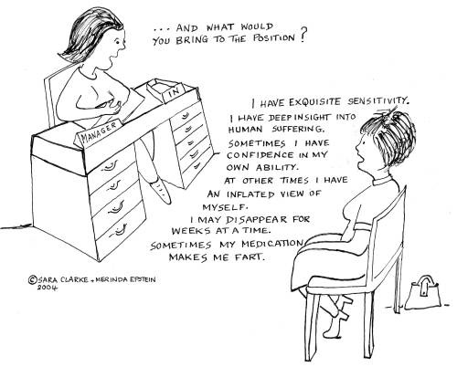
Figure 1. And what would you bring to the position?
Importantly, this cartoon clearly states some valuable aspects of lived experience of “mental illness”. These experiences are usually tolerated at best; more often than not (if we are to be truly honest), they are understood as “problems to be fixed.” It’s rare to see specific articulation of the value of lived experiences – specifically here she points to “exquisite sensitivity,” “deep insight into human suffering” and perhaps other abilities.
But the cartoon also speaks of other things that we usually don’t talk about, shameful things: grandiosity, discomforting and confusing behaviour and embarrassing bodily functions. All of these things are in the realm of shame, and what I call the “abject.” I’ll come back to that concept later. When confronted with the abject, we tend to use defence mechanisms – we laugh reading this cartoon, but there is a larger cultural silence out there.
My positionality
I come to this topic from a few directions. Firstly, I draw on my own lived experience of being labelled with “mental illness.” Secondly, I work at an organisation called Our Consumer Place (OCP, www.ourconsumerplace.com.au), which values lived experiences of “mental illness” and works for a cultural shift whereby our experiences are valued and our leadership fostered. We use a humorous postcard to publicise our organisation. On the front is a Lichtenstein-style image of a woman, who has made a disturbing realisation – “Oh my, four in five don’t have a mental illness?? All those poor sane people…” On the back, the text reads:
“You are not alone, we are all over the place …
Our Consumer Place is a resource centre run entirely by people diagnosed with ‘mental illness’. Those of us diagnosed with ‘mental illness’ have a valuable perspective to offer. Our lived experiences are varied and rich: some of us experience madness, psyche-ache, emotional distress, hearing voices, mental breakdown or ‘mental illness.’ We don’t all make meaning from our experiences in the same way. Many have used or survived mental health services, others haven’t. Many of us have experienced prejudice, exclusion and trauma. Many of us have hidden our experiences, some of us are ‘out’ in various ways.
We all share the ability to reflect on our lives, our communities and the ‘mental health system’ from the perspective of our lived experience. Our Consumer Place is a resource for our voices to come together.”
A few points are worth making about the way we are positioning ourselves. Firstly, we are not calling for consumer “participation,” “inclusion” or “involvement.” Our vision is much broader and deeper than that. It is also notable that our materials assume that our reader may be someone who themselves has a “mental illness.” That is, we address other consumers as subjects to be engaged with, rather than objectifying and talking “about them” as most mental health texts do.
I also come to this as a Critical Consumer Academic. I am nearing the completion of my PhD, which is in sociology/social theory, but draws on a number of disciplines, including critical disability studies, whose knowledge has been marginalised. My thesis is an examination of texts that appear to be “benevolent” about the “other.” What this looks like in practice is that I take photographs of any text in public space that looks (to me) like it’s “trying to be positive” about some form of marginalised identity – so, for example, billboards urging us to “celebrate multiculturalism,” “close the gap,” “see the person, not the disability,” or “support gay marriage.”
My thinking is that these texts tend to massively oversimplify the issues, glossing over complexities and silencing uncomfortable aspects of living in diversity. They also usually silence the voices and lived experiences of those of us who are being “othered.” Rather than face the complexities and discomforting questions around living in diversity, these texts opt for an incitement to what I call “benevolent subjectivity” – that is, good, “normal” people (those who are not being “othered”) get to feel comfortable in their benevolence, their good feelings, without actually changing or being changed by living in diversity. In this process, the potential for meaningful social change is scuttled. While the rest of this paper focuses on mental health, I want to be clear that this is a broader social phenomenon.
Finally, this paper is also connected with my work as part of the organizing committee for the inaugural “Borderline Personality Disorder Awareness Day” in Melbourne, October 5th 2011. More than most diagnoses, BPD presents challenges to this whole idea of “positive thinking” about consumers.
“Anti-stigma campaigns”
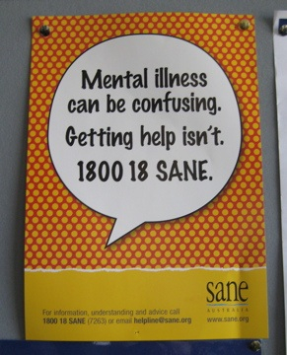
So, here are some texts from my PhD corpus, specific to mental health. I want to draw your attention to some parts of these that don’t sit well with me.
Figure 2: SANE

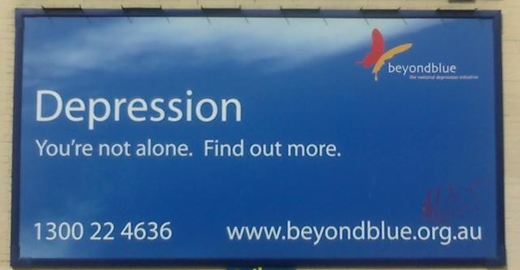
Figure 3: Beyond Blue (1)

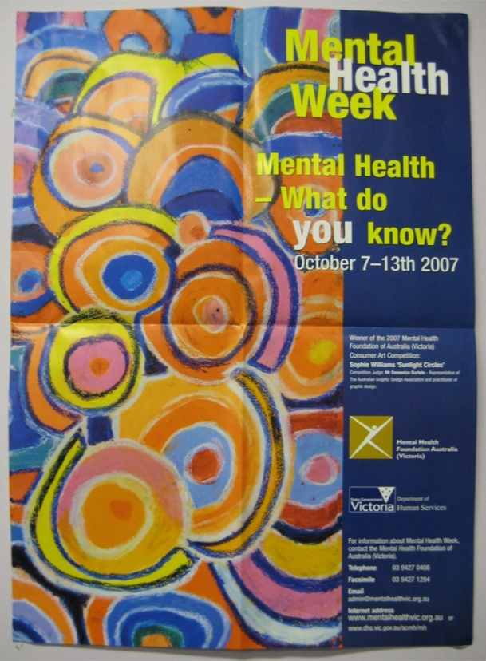
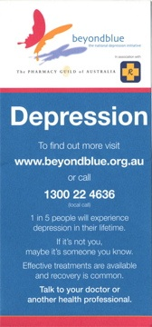
Figure 4: Mental Health Week

Figure 5:
Beyond Blue (2)

In figure 2, SANE advise us that “Mental illness can be confusing,” which is of course true for many consumers. But then they add that “Getting help isn’t.” Perhaps that is true for some people, but that’s certainly not my lived experience! Here we have a massive simplification and silencing of the lived experience of many consumers – a glossing over the experience that accessing services can be fraught: confusing, confronting, coercive, disappointing and shaming. But such things can be difficult to talk about.
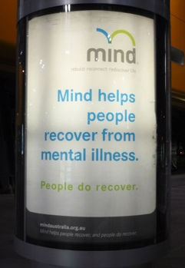
In figure 3, Beyond Blue state: “Depression. You’re not alone. Find out more.” And figure 4 asks “Mental health week – what do you know?” Such texts beg the question – who you would ask to “find out more”? This is a question of epistemology – of how we come to “know” what we know – and of who has legitimate expertise. Figure 5 offers one answer, advising that you should “talk to your doctor or another health professional”
Figure 6: Mind

Most of these texts are produced by mental health charities, and function as claims that these mental health charities are the appropriate experts you can turn to – indeed this is arguably their primary function. So, for example, figure 6 advises us that “Mind helps people recover from mental illness. People do recover” My question here is – is this really “destigmatising” work or an advertisement for Mind (and a colonising of the term “recovery”)? The same could be said of Beyond Blue’s “highly successful” anti-stigma campaign, where “successful de-stigmatising” appears to be blurred with brand-recognition:
Beyondblue's mission to destigmatise depression has been an unrivalled success, with 87 per cent of Australians aware of the organisation. (The Age, Oct 9th, 2011)

Figure 7: SANE (2)
Figure 7 could point us in an entirely different direction, asking the reader “Even though I have a mental illness, don’t you think we could have a conversation?” This notion of a genuine conversation is pivotal to progress in changing social attitudes. But there is a disjunct in this text – the person’s face isn’t visible, and so engagement is actually disallowed. This is another example of abjection – a concept I mentioned earlier and will return to later.
Mind helps people recover
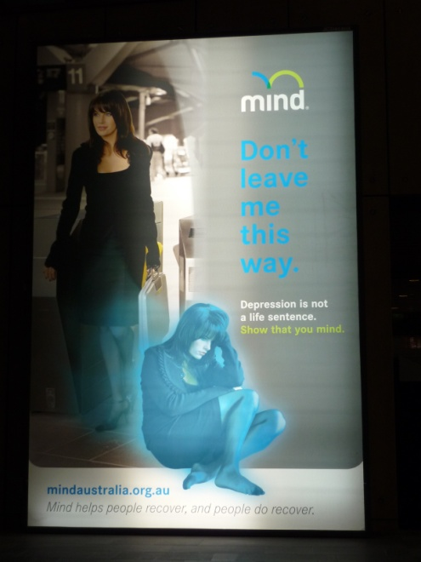
Figure 8: Mind (Depression)

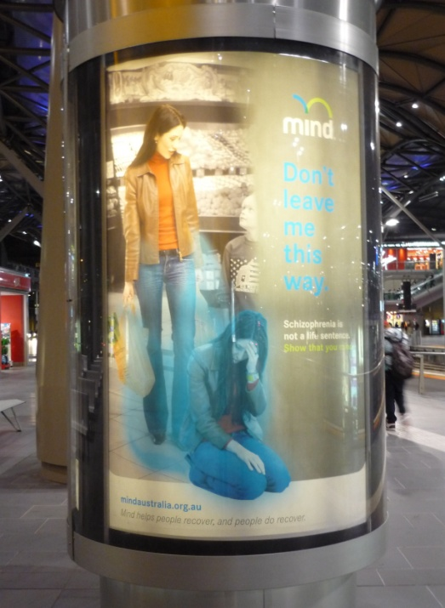
Figure 9: Mind (Bipolar)

The advertisements discussed in this section were massive, at Southern Cross train station in Melbourne – I live in the country and commute by train so I saw these whenever I came into work.

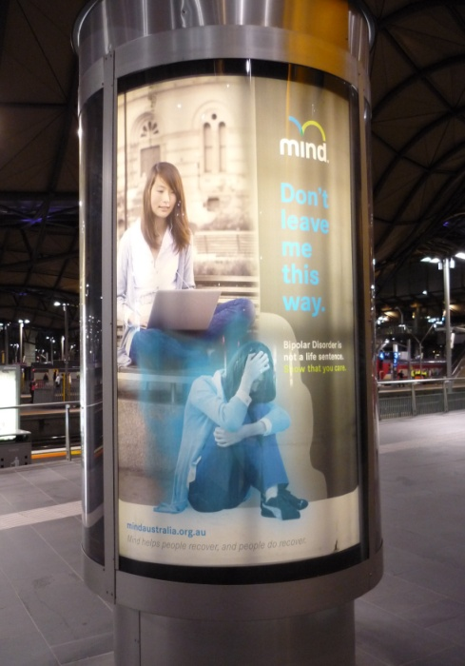
The main text reads: “Mind. Don’t leave me this way. Depression (figure 8) / Bipolar (figure 9) / Schizophrenia (figure 10) is not a life sentence. Show that you mind.” The way I read them is that on the left of each of the images, we have happy person, living a visibly “normal” life. Then in the middle, we have a problem, the same person huddled in a visibly distressed state, imploring us to help them or for Mind to help them. The image is the same for each of the 3 diagnoses rendered “visible” –depression, bipolar and schizophrenia. It is interesting to observe the repetition of the visual language – in each case, the woman is well-dressed, respectable-looking, and in no way threatening or challenging.
One question I have is what might the image look like if this woman was diagnosed with Borderline Personality Disorder. I’m mindful here of not being simplistic or stereotyping, but perhaps such an image might not be quite so sympathy-arousing and pitiful. There might be a razor blade and blood, or she might be saying “Fuck off! I don’t want your fucking help!”
Figure 10: Mind
(Schizophrenia)

I use BPD as an example, but similar things could be said for other experiences. Perhaps the person might be saying “leave me alone, your interventions are patronising and insulting” or “No I don’t want involuntary ECT, thank you very much” or “my medication is making me fat, lethargic, lose my sex drive and dribble.” Or the person could be acting in ways that are confusing or distressing to witness. Or the person may be unwashed, smelly and high. In other words, she might not appear quite so straightforwardly “deserving of sympathy.”
But instead of visually representing any of these uncomfortable, abject elements associated with “mental illness,” Mind chooses to use relatively safe, sanitised images of what I call “visible sadness.”
“I no longer feel ashamed” because I have a chemical imbalance
Another “de-stigmatization” approach is to medicalize the experiences. So, for example, there is an Avant card (the kind you can pick up in cafes) which reads: “My ability to dream of the future returned and I no longer felt ashamed to be someone living with a mental illness” The image is of a man, peering into a box, from which is emerging a rainbow, with the text written along it. The image has no other context.
And then on the back we are given a reassuringly medicalised description of what bipolar “is” (from the positionality of medical expertise).
Bipolar Disorder is an illness that results from an imbalance of chemicals in the brain, which can cause extreme fluctuations of mood from the heights of mania (elevated mood which may be out of character for the individual) to the depths of depression (persistent low mood). Everyone experiences happiness and sadness, however those who live with Bipolar Disorder feel these mood changes at an exaggerated level. The changes are often referred to as cycles or episodes. If you are having similar episodes please consult your doctor. Go to our website www.bipolar.com.au for the new story of hope.
You might note the language is objectifying, and only ambivalently addresses people with bipolar – it moves between engagement with people with this diagnosis as subjects, and objectification. Also, I would argue that the assumed relationship between shame and medicalization (that realising one has an imbalance of chemicals in the brain leads directly to no longer feeling ashamed) warrants more unpacking.
But now I want to juxtapose these “anti-stigma” campaigns with more of Merinda’s cartoons.
The three faces of distress
I find this cartoon (figure 11) useful in helping to think through what’s going on in anti-stigma work. I suggest that most “anti-stigma” work focuses on either “the sad” or “the mad.” In either case, they may use objectifying medical expertise – “madness” especially is reassuringly left to “the experts”, who will help “them”.
Sometimes, anti-stigma work draws on pity (because it’s easier to feel benevolence towards someone who is “sad” or medically-legitimately “mad”).
But some of us are left in the category of “bad,” for various reasons. For example, having a “personality disorder,” or being “non-compliant,” or “lack of insight”, or being ungrateful, or being enveloped in cultural silence, or shame, or not “recovering” on schedule.
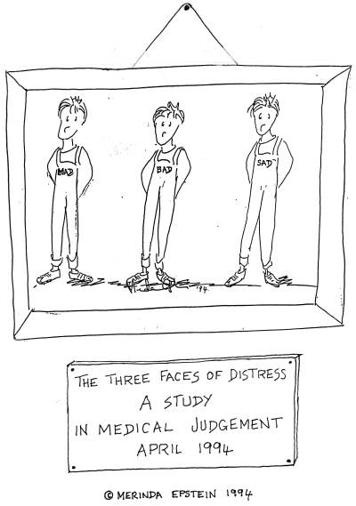
Figure 11: The three faces of distress

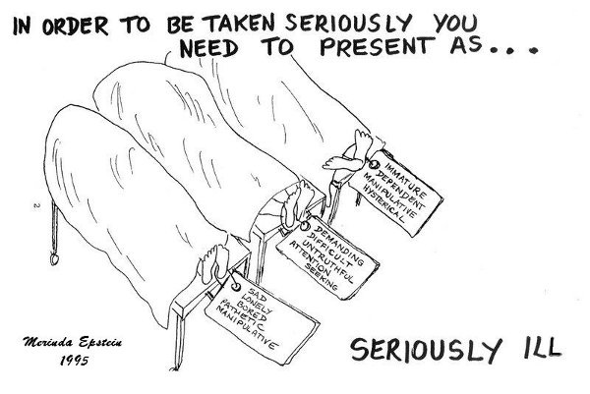
Figure 12: In order to be taken seriously
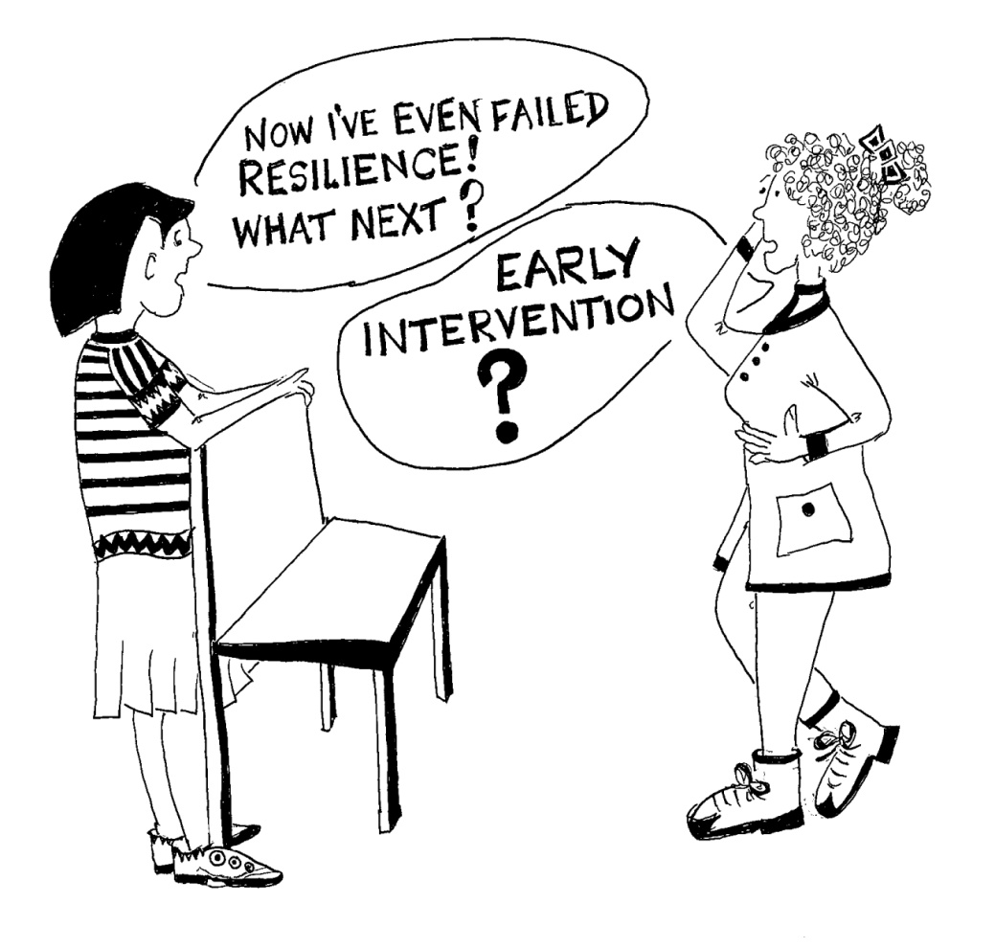

© Merinda Epstein 2011
Figure 13: Now I’ve even failed resilience

Some conceptual interventions
So, I want to place some of the ideas that have been suggested so far within some conceptual framework (the actual terminology may or may not be useful to you, but I hope the concepts are).
Abjection: The first is abjection from the work of Julia Kristeva. The abject is that which exists on the margin, it’s disorderly, rejected and repulsive: things like bodily fluids, sexuality and madness. Most people are familiar with the phrase “abject poverty”. It’s also a word that can be used to describe the state of marginalised groups, such as prostitutes, queers, criminals, poor people and disabled people. Kristeva writes of the abject that it disturbs identity, system, order: it does not respect borders, positions, rules.
I find the concept useful to refer to those parts of our lived experiences that are confronting to talk about – discomforting emotions, self-harm, unpredictable behaviour, bodily fluids, the farting from Merinda’s cartoon. All too often we are afraid of the abject: at both a cultural and individual level, we struggle with it.
Finally, I want to introduce a pair of terms: stigmaphilia and stigmaphobia, which raise the question of why don’t I just talk about stigma instead of abjection?
I don’t find the term stigma the least bit useful. It is vague, unproductive and has been entirely colonised. In my research, I see it being used to mean something like “community ignorance” about “the reality of mental illness,” where the “reality” is to be dispensed by “mental health experts” (by training), through narrowly conceived, hierarchical approaches to “community education.”
But the elephant in the room is that mental health services themselves are arguably the most stigma-laden domain in our society. So, the very experts (by training) who position themselves as combating stigma are ironically often part of the problem. Most importantly, the “realities” of mental illness that are presented usually gloss over the lived realities, especially the discomforting parts, the abject, and so effectively silence those of us who live with “mental illness.”
However, I do find the terms stigmaphobia and stigmaphilia generative in my own thinking. They come from the work of queer theorist Michael Warner (1999). Ultimately, both are about how we respond to abjection (they were originally theorised as responses to “stigma”).
A stigmaphilic response (stigma + philia (love)) embraces and celebrates abjection. Warner uses the example of queers who are overtly sexual and confrontational. In the context of mental health, I would suggest that mad pride is a stigmaphilic response, as is a postcard that reads “I don’t suffer from insanity, I enjoy every minute of it.”
But stigmaphobia is the concept that I’m really interested in. Stigmaphobia, involves rejecting and displacing abjection. Crip theorist, Michael Berube, who uses Warner’s work in the context of disability, writes ‘you find people scrambling desperately to be included under the umbrella of the "normal"’ - and in so doing, they ‘cast somebody else as abnormal, crazy, abject, or disabled.’ (2006:viii)
So, in the larger cultural realm into which these texts intervene, I argue Beyond Blue has quite successfully applied a stigmaphobic logic to rehabilitate depression and anxiety, removing them from the realm of the abject. But in so doing, they have cast a shadow over other diagnoses and experiences, the especially abject experiences. They’ve also rendered some aspects of depression and anxiety – the abject parts – harder to talk about.
Some concluding words: what I desire
I want our experiences to be “speakable.” This is not the place I want to speak about my own darkest, most shameful experiences, but I don’t want there to be a cultural silence around them. This perpetuates shame.
I want dialogue. I don’t want mental health charities or what I sometimes call “experts by objectification” to tell people about the “realities” of mental illness. I want real human conversations that most especially respect and engage with the realities of our lives.
I want society to change, to be changed by our presence. I don’t want tolerance and the right to participate in “normal” life, I want the world to value what I have to offer. to desire my presence, not benevolently allow it.
I want us all to broaden our capacity to sit with and move through discomfort and complexity. And ultimately, I want a flourishing of the human spirit.
And finally, here’s one more cartoon from Merinda, because I want to embrace the joy in all of this.
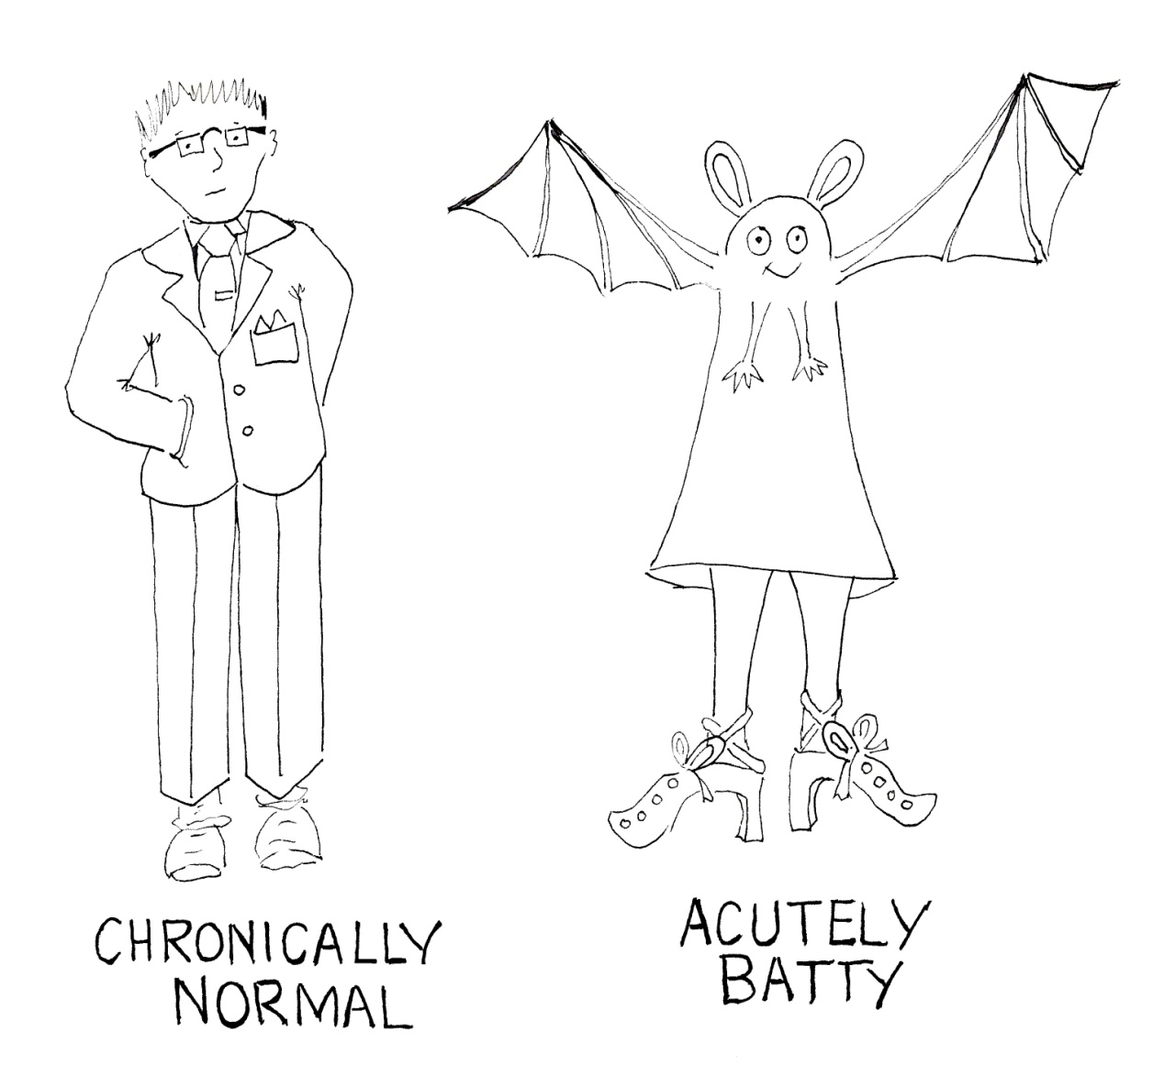
© Merinda Epstein 2010
Figure 14: Chronically normal

References
Berube, Michael, 2006, Forward to Robert McRuer Crip Theory: cultural signs of queerness and disability, Cultural Front, New York.
Epstein, Merinda, n.d. A Consumer Activist’s Guide to Mental Health in Australia: www.takver.com/epstein

Stark, Jill and Melissa Fyfe, October 9th, ‘What lies Beyond’ http://www.theage.com.au/national/what-lies-beyond-20111008-1lf37.html#ixzz1aKlogExw
Warner, Michael, 1999, The trouble with normal: sex, politics, and the ethics of queer life, Free Press, New York.

